Contact: Bob O’Donnell  TECHnalysis Research, LLC  Phone (650) 224-2355  bob@technalysisresearch.com |  | 
Press Release

Android Leads in Custom Mobile Application Development for Enterprise

Study Shows Most Companies Still in Early Stages; Limited Support for BYOD Devices
Foster City, CA -- January 14, 2015: As smartphones and tablets have become mainstream devices in businesses of all sizes, companies have started placing more efforts on building custom applications for these critically important mobile devices. But as a recent study by TECHnalysis Research shows, their efforts are clearly in the early stages, and are still playing catch-up to the influential world of custom PC applications in business.
Based on a survey of 485 US-based IT professionals from small (10-99 employees), medium (100-999 employees) and large (1,000+ employees) businesses involved with the creation and deployment of custom applications for their businesses, TECHnalysis Research found that 98% of companies have built custom PC applications, while 81% have built custom smartphone apps and 78% have built custom tablet apps. Only 62% of small businesses have built custom apps for tablets while 96% of that group have built custom PC apps.
The different levels of engagement these businesses show towards custom mobile apps also extend to the range and type of employees using those apps. Survey results showed that for companies of all sizes using custom PC apps, 71% of those apps are being used by all employees, while total employee usage is just 43% for custom smartphone apps and 37% for custom tablet apps. In the case of both custom smartphone and tablet apps, top-level executives have the highest usage at 47% and 53% respectively, suggesting these apps are cherry-picked projects built by special request from top company execs.
“While the hype around mobility in the enterprise is reaching fever-pitch levels, it’s clear that many businesses are really just getting started,” said TECHnalysis Research Founder and Chief Analyst Bob O’Donnell. “Custom PC application trends still have a strong impact on mobile apps in business, and the next several years are going to be crucial in determining the winners and losers in this critical category.”
The study also found some surprising trends regarding application type and platform preference. Only about 1/3 of custom apps being built for business are stand-alone applications; most are a combination of front-ends to large enterprise applications, companion apps for existing desktop applications, and utilities. In terms of platforms supported, Android was the top choice overall with 40% of both smartphone and tablet apps being built on Google’s mobile platform versus 39% for iOS on smartphones and 34% for iOS on tablets. Windows support on tablets was surprisingly strong at 26%, reflecting the heritage of custom Windows PC applications as well as the skill set of custom app programmers within many businesses. The chart below highlights the platform choices by device type.
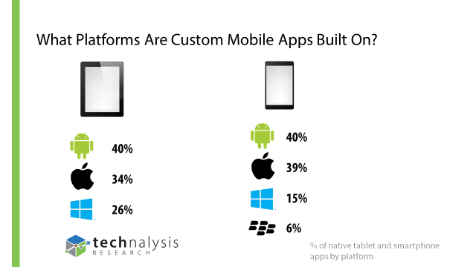
Another surprising outcome from the study involved the degree of support that businesses are providing for BYOD devices when it comes to business applications. In sum, 18% of companies said they are installing custom apps on BYOD PCs versus 38% on BYOD tablets and 45% on BYOD smartphones. However, on company-purchased PCs, 98% of respondents are installing custom applications, while custom apps are installed on 89% of company-purchased tablets and 87% of company-purchased smartphones.
“These numbers clearly reflect reticence on the part of IT to deploy their new applications onto devices they don’t directly own and tightly manage,” said Mr. O’Donnell.
Highlights of the study are available in slide format at no charge upon request and a copy of the complete report is available for purchase from TECHnalysis Research. For additional information, please e-mail the author at bob@technalysisresearch.com.
Founded by technology market research veteran Bob O’Donnell, TECHnalysis Research, LLC provides strategic consulting and market research services to the technology industry and professional financial community. Building on a deep understanding of critical technology and business trends, in conjunction with hard-hitting, original research, the firm provides unique "out-of-the-box" perspectives that are still grounded in the practical realities of the technology, media and telecom markets.

